**ARKcASE   
tRAINING gUIDE**

**For User Admin Training Participants**

Abstract

This training will provide you with base knowledge you will need to begin working with ArkCase.



**Table of Contents**

**1** **ArkCase Installation** 3

**1.1** **Global Architecture** 3

**1.2** **Architecture for this training** 3

**1.3** **Install Components** 4

**1.4** **Download Training Materials** 5

**1.5** **Configure Components** 6

**1.6** **Tomcat TLS Configuration** 6

**1.7** **Configure OpenVPN (Only for the training)** 7

**1.8** **Component Verification** 7

**1.9** **Install missing libraries and tools** 8

**1.10** **Connect to the AMI instance VPN** **(Only for the training)** 8

**1.11** **Download ArkCase, Config Server and .arkcase folder from GitHub** 8

**1.12** **Host file and Windows Firewall** 9

**1.13** **Set lower Node.js version** 10

**1.14** **Build and start Config Server** 10

**1.15** **Build and start ArkCAse** 11

# **ArkCase Installation**

**Day 1 - 05/31/2021**

**Setting Up ArkCase**

## **Global Architecture**

## **Architecture for this training**

For training purposes let’s use one folder where we will work and install ArkCase and needed components. Let’s create one folder named “Training” (we will call **{training.folder}** in the next pages):

* Windows
  + **C:Users/<USERNAME>/Training**
* MacOS
  + **/Users/<USERNAME>/Training**

Next, let’s start with downloading and installing all needed components for successful installation:

## **Install Components**

* Install OpenJDK 1.8.0
  + Windows
    - Download OpenJDK and install at default path: <https://github.com/ojdkbuild/ojdkbuild/releases/download/java-1.8.0-openjdk-1.8.0.222-1.b10/java-1.8.0-openjdk-1.8.0.222-1.b10.ojdkbuild.windows.x86_64.msi>
  + MacOS
    - (Skip this step if you already have **brew**) Install brew
      * **/bin/bash -c "$(curl -fsSL https://raw.githubusercontent.com/Homebrew/install/master/install.sh)"**
      * Resource: <https://brew.sh/>
    - **brew search /adoptopenjdk/**
      * seach for **adoptopenjdk8**
      * if you don’t have **adoptopenjdk8**, do the following command
      * **brew tap AdoptOpenJDK/openjdk**
    - **brew cask install adoptopenjdk8**
    - Resource: <https://dzone.com/articles/install-openjdk-versions-on-the-mac>
* Install Tomcat 9.0.54
  + Main download URL: <https://downloads.apache.org/tomcat/>
  + Download URL for this training <https://downloads.apache.org/tomcat/tomcat-9/v9.0.54/bin/apache-tomcat-9.0.54.zip>
  + Extract the content of **apache-tomcat-9.0.54.zip** in the **{training.folder}**
  + At the end, Tomcat folder installation should be **{training.folder}/apache-tomcat-9.0.54** and bin folder should be **{training.folder}/apache-tomcat-9.0.54/bin** (this is confirmation that you extracted tomcat on a proper way)
  + Create folder named **logs** in the **{training.folder}/apache-tomcat-9.0.54/bin** folder
* Install Maven (3.3 or later)
  + Main download URL: <https://maven.apache.org/download.cgi>
  + Download URL for this training: <https://downloads.apache.org/maven/maven-3/3.8.3/binaries/apache-maven-3.8.3-bin.zip>
  + Extract the content of **apache-maven-3.8.3-bin.zip** in the **{training.folder}**
  + At the end, Maven folder installation should be **{training.folder}/apache-maven-3.8.3** and bin folder should be **{training.folder}/apache-maven-3.8.3/bin** (this is confirmation that you extracted tomcat on a proper way)
* Install Node.js
  + Windows
    - <https://nodejs.org/download/release/v12.14.1/node-v12.14.1-x64.msi>
  + MacOs
    - <https://nodejs.org/download/release/v12.14.1/node-v12.14.1.pkg>
  + Execute the msi/pkg file and follow instruction for installation
    - For MacOS
      * If Mac does not allow then go to System Preferences -> Security & Privacy -> General (you should see the error at ‘allow apps downloaded from’). Click on that error and allow it to be installed.
      * Make sure that **/usr/local/bin** is in your **$PATH**
  + Resource: <https://nodejs.org/download/release/v12.14.1/>
* Install IDE (Intellij IDEA, STS or any IDE that you are familiar with for Java programming. NOTE: For this training purposes, we will use Intellij IDEA evaluation copy. If you choose to use different IDE, then you should change some steps below corresponding your IDE choice):
  + <https://www.jetbrains.com/idea/download>[/](https://www.jetbrains.com/idea/download/)
* Install Yarn
  + <https>[://yarnpkg.com/en/docs/install](https://yarnpkg.com/en/docs/install)
* Install Grunt
  + <http://gruntjs.com/getting-started>
  + Open CMD (Command Prompt) and execute the command **npm install -g grunt-cli**
* Install Git
  + <https://git-scm.com/downloads>
* (Only for the training) Install OpenVPN Client
  + Windows
    - <https://swupdate.openvpn.org/community/releases/openvpn-install-2.4.9-I601-Win10.exe>
  + MacOS
    - <https://openvpn.net/downloads/openvpn-connect-v3-macos.dmg>
  + Execute the exe/dmg file and install OpenVPN
  + Resources
    - Windows
      * <https://openvpn.net/community-downloads>[/](https://openvpn.net/community-downloads/)
    - MacOS
      * <https://openvpn.net/vpn-server-resources/connecting-to-access-server-with-macos/>

## **Download Training Materials**

1. Open Git Bash/Terminal and go to the folder **{training.folder}** with the following command
   * **cd {training.folder}**
2. Download **Documentation** from GitHub:
   * Clone the **Documentation** repository
     + git clone <https://github.com/ArkCase/Documentation.git>
     + Enter your GitHub credentials if asked
   * Checkout the “main” branch
     + git checkout main

## **Configure Components**

After installing every component from point 1.3, we need to configure some of them. Please follow below instructions to configure them:

* Check/Set **JAVA_HOME** environment variable, pointing to the top-level JDK (not the JRE) folder
  + Windows
    - **JAVA_HOME** should have value **C:/Program Files/ojdkbuild/java-1.8.0-openjdk-1.8.0.222-1**
  + MacOS
    - **JAVA_HOME** should have value **/Library/Java/JavaVirtualMachines/adoptopenjdk-8.jdk/Contents/Home**
* Open the file **%JAVA_HOME%/jre/lib/security/java.security** and uncomment (remove #) if commented the **crypto.policy** property. Make sure its value is set to **unlimited**
  + **crypto.policy=unlimited**
* Update your **PATH** environment valuable to include the Maven bin folder
  + In our case the value added to the **PATH** variable should be **{training.folder}/apache-maven-3.8.3/bin**
  + MacOS
    - Update **.profile** to set the path
      * **export PATH=$PATH:{training.folder}/apache-maven-3.8.3/bin**
    - Load **.profile** for changes to have effects
      * **source .profile**
* Go to the **{training.folder}/Documentation/Training/ArkCase-201** folder and find **settings.xml** file. Put it to the **.m2** subfolder under your home folder (create the **.m2** subfolder in your home folder if it doesn't exist already). Your home folder is:
  + Windows
    - **C:/Users/<USERNAME>**
  + MacOS
    - **/Users/<USERNAME>**
  + Replace **<USERNAME>** with your actual PC username

## **Tomcat TLS Configuration**

* Add HTTPS connector
  + In your Tomcat 9 installation open the file **server.xml** (**{training.folder}/apache-tomcat-9.0.54/conf/server.xml**), and add the following connector, below the existing connector for port 8080:  
      
    *<!-- ArkCase Connector -->*

*<Connector port="8843"*

*maxThreads="150" SSLEnabled="true" secure="true" scheme="https"*

*maxHttpHeaderSize="32768"*

*connectionTimeout="40000"*

*useBodyEncodingForURI="true"*

*address="0.0.0.0">*

*<UpgradeProtocol className="org.apache.coyote.http2.Http2Protocol" />*

*<SSLHostConfig protocols="TLSv1.2" certificateVerification="none">*

*<Certificate certificateFile="${user.home}/.arkcase/acm/private/acm-arkcase.crt"*

*certificateKeyFile="${user.home}/.arkcase/acm/private/acm-arkcase.rsa.pem"*

*certificateChainFile="${user.home}/.arkcase/acm/private/arkcase-ca.crt"*

*type="RSA" />*

*</SSLHostConfig>*

*</Connector>*

*<!-- ArkCase Connector -->*

* In the same file, **{training.folder}/apache-tomcat-9.0.54/conf/server.xml,** search for the text **Listener className="org.apache.catalina.core.AprLifecycleListener",** and make sure to add the **useAprConnector="true"** attribute, so it ends like this:
  + *<Listener className="org.apache.catalina.core.AprLifecycleListener" SSLEngine="on" useAprConnector="true"/>*
* (Optional) In the same file, **{training.folder}/apache-tomcat-9.0.54/conf/server.xml,** Change the shutdown port from -1 to 8005
  + *<Server port="8005" shutdown="SHUTDOWN">*
* MacOS
  + **chmod a+x {training.folder}/apache-tomcat-9.0.54/bin/catalina.sh**

## **Configure OpenVPN (Only for the training)**

* Start OpenVPN GUI at your PC
  + Windows: Click OK when the first popup is shown
* Go to the **{training.folder}/Documentation/Training/ArkCase-201** folder and find **config.ovpn**
* Open the file **config.ovpn** in text editor and replace **AMI_INSTANCE_DNS** with your AMI instance DNS
* Windows
  + Put the file in **C:/Users/<USERNAME>/OpenVPN/config**
  + Replace **<USERNAME>** with your actual PC username

## **Component Verification**

We must be sure that all components are configured properly. Open CMD (Command Prompt) as Administrator and execute the following commands one by one. Verify that the commands work and produce some output that shows the version of the various tools:

* java -version
* npm -version
* git --version
* yarn -version
* mvn -version

## **Install missing libraries and tools**

Execute the following commands to install missing libraries and tools that are needed for successful ArkCase start. Please do that with Administrator privileges:

* Windows
  + **npm install --global --production windows-build-tools --vs2015**
* MacOS
  + Install Python 2.7.15
    - <https://www.python.org/ftp/python/2.7.15/python-2.7.15-macosx10.9.pkg>
  + **npm install xcode-build-tools**

## **Connect to the AMI instance VPN** **(Only for the training)**

Windows

* Right click on the OpenVPN icon in system tray and click **Connect** (you should connect to the AMI instance VPN successfully)

MacOs

* Open OpenVPN GUI
* Click on **File** tab at the login screen
* Browse **{training.folder}/Documentation/Training/ArkCase-201/config.ovpn**

## **Download ArkCase, Config Server and .arkcase folder from GitHub**

In the folder that we created at the start of this training, **{training.folder}**, we are going to download ArkCase, Config Server and .arkcase folder:

1. Open Git Bash/Terminal and go to the folder **{training.folder}** with the following command
   * **cd {training.folder}**
2. Download ArkCase from GitHub:
   * Clone the ArkCase repository
     + git clone <https://github.com/ArkCase/ArkCase.git>
     + Enter your GitHub credentials if asked
   * Checkout the “main” branch
     + git checkout main
3. Download Config server form GitHub:
   * Clone the Config Server repository
     + git clone <https://github.com/ArkCase/acm-config-server.git>
     + Enter your GitHub credentials if asked
   * Checkout the “main” branch
     + git checkout main
   * (Only for the training purposes):
     + Copy and replace entire folder **{training.folder}/Documentation/Training/ArkCase-201/acm-config-server** to the folder **{training.folder}/acm-config-server**
4. Download .arkcase from GitHub in your home folder:
   * Go to your home folder (we will call it **{home.folder}**)
     + Windows
       - **cd /c/Users/<USERNAME>**
     + MacOS
       - **cd /Users/<USERNAME>**
     + Replace **<USERNAME>** with your PC username
   * Clone .arkcase repository
     + git clone <https://github.com/ArkCase/.arkcase.git>
   * Checkout the “main” branch
     + git checkout main
   * (Only for the training purposes):
     + Copy and replace entire folder **{training.folder}/Documentation/Training/ArkCase-201/acm** to the folder **{home.folder}/.arkcase/acm**

## **Host file and Windows Firewall**

Add the IP address of the AMI instance to your host file

* Windows
  + Open file **C:\Windows\System32\drivers\etc\hosts** in text editor with Administrator privileges
* MacOS
  + Open /etc/hosts with sudo
    - **sudo vi /etc/hosts**
* Add this line:
  + **10.8.0.1 arkcase-ce.local**

Windows Firewall - execute the following commands in CMD (Command Prompt) with Administrator privileges

* Configure the Windows firewall to allow incoming ICMP (ping) traffic
  + **netsh advfirewall firewall add rule name="ICMP Allow incoming V4 echo request" protocol=icmpv4:8,any dir=in action=allow**
* Allow incoming traffic on port 8843
  + **netsh advfirewall firewall add rule name="Open Port 8843" dir=in action=allow protocol=TCP localport=8843**

## **Set lower Node.js version**

Previously we installed Node.js version v12.14.1 because we needed some tools that this package contains for successful installation for the components. But for ArkCase start, we need lower version. Let’s set lower version. Do the following steps:

* Windows
  + Install NVM tool
    - Download <https://github.com/coreybutler/nvm-windows/releases/download/1.1.7/nvm-setup.zip>
    - Extract the **nvm-setup.zip** and execute the exe
    - Follow the default installation steps
    - Resource: <https://github.com/coreybutler/nvm-windows/releases>
  + Open CMD (Command Prompt) with Administrator privileges and execute the following commands
    - **nvm list** (check all your local Node.js versions)
    - **nvm install 10.18.1** (you should install this Node.js version)
    - **nvm use 10.18.1** (you should use this Node.js version)
* MacOS
  + Download and install <https://nodejs.org/dist/v10.18.1/node-v10.18.1.pkg>

## **Build and start Config Server**

To build and/or start the Config Server, navigate to the folder where the Config Server is located with Git Bash. In our case in **{training.folder}\acm-config-server**:

* Build the Config Server
  + **mvn clean install**
* Start the Config Server
  + **java -jar target/config-server-2021.02.jar**
* Check if the config server is up and running
  + <http://localhost:9999/arkcase/runtime>

The config server runs on port **9999** by default. If you want to run on different port, you will need to add the argument **-Dserver.port=XXXX**. For this training we will use the default port **9999.**

## **Build and start ArkCAse**

Let first build the ArkCase. Navigate to the folder where the ArkCase is located either with CMD or Git Bash. In our case in **{training.folder}\ArkCase**:

* Build the Config Server
  + **mvn clean install -DskipITs -DskipTests**
    - **-DskipITs** will skip all integration test
    - **-DskipTests** will skip all jUnit tests
    - We are doing this skip at the training just to speed up the process
* Start ArkCase (through IDE)
  + Open Intellij Idea
  + Start Evaluation If you don’t have license for it  
    A screenshot of a cell phone

    Description automatically generated
  + Click on **Open Or Import** button  
    A screenshot of a cell phone

    Description automatically generated
  + Or if the Intellij IDEA is already opened, go to **File->New->Project from Existing Sources…**  
    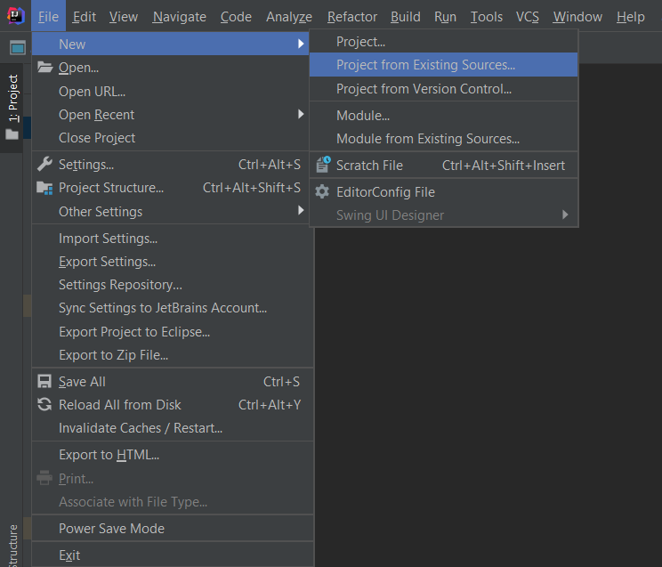
  + Select ArkCase project from the path **{training.folder}\ArkCase**
    - NOTE: wait while indexing and processes are in progress
  + Create Local Tomcat configuration
    - Click Add Configuration button on top-right side  
        
      A screenshot of a computer

      Description automatically generated
    - Click **+** sign, go to **Tomcat Server**, then **Local  
      A screenshot of a video game

      Description automatically generated**
    - Server tab:
      * Name: ArkCase Core (or any name that you want)
      * Application Server
        + Click on **Configure** button
        + Select your Tomcat installation (select folder **C:\Training\apache-tomcat-9.0.54**)  
          A screenshot of a cell phone

          Description automatically generated
      * URL: [**https://arkcase-ce.local/arkcase/**](https://arkcase-ce.local/arkcase/)
      * VM Options: **-Duser.timezone=GMT -Djavax.net.ssl.trustStorePassword="@rKc@3e" -Djavax.net.ssl.trustStore="{home.folder}/.arkcase/acm/private/arkcase.ts" -Dspring.profiles.active=ldap -Dacm.configurationserver.propertyfile="{home.folder}/.arkcase/acm/conf.yml" -Xms1024M -Xmx1024M**
        + **{home.folder}**

Windows

**C:/Users/<USERNAME>**

MacOS

**/Users/<USERNAME>**

Replace **<USERNAME>** with your PC username

* + - * HTTP Port: 8080

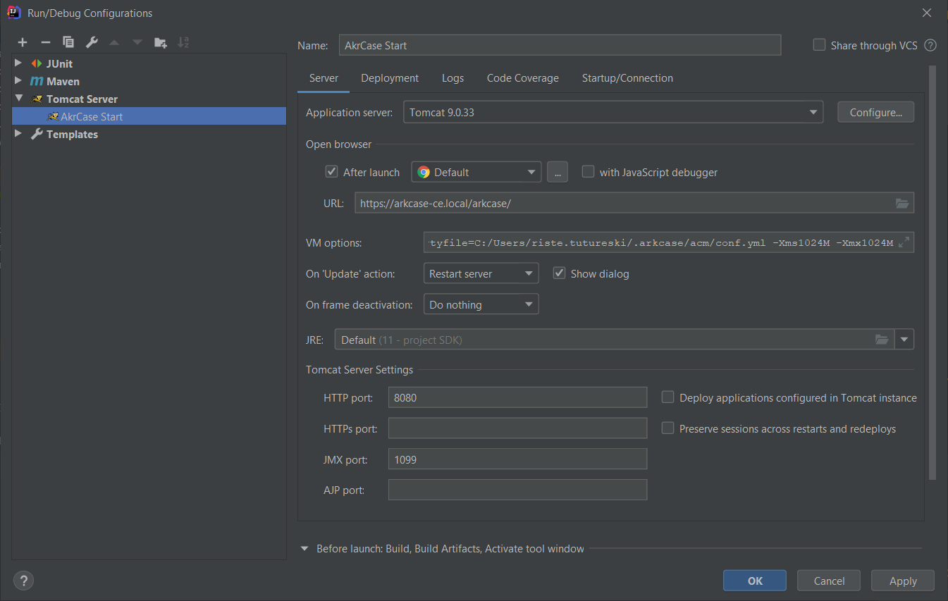

* + - Deployment tab:
      * Click on the **+** sign
      * Click **Artifacts…**
      * Select **arkcase:war**
      * Application Context: **/arkcase**

* + (Optional)
    - If you have problem with starting ArkCase, do the following steps
      * Go to **{training.folder}/ArkCase/acm-standard-applications/acm-law-enforcement/src/main/webapp/resources**
      * Do the following commands with Administrator privileges
        + **npm i -g npm-check-updates**
        + **npm-check-updates -u**
        + **npm install node-sass**
  + Press Start button
    - Be sure that you have started the Config Server
    - Be sure that you have connected to the AMI via OpenVPN (for the training)
* Start ArkCase from Tomcat:
  + If your IDE of choice is not supporting starting WAR files from it, you can take the result of ArkCase build, the war file **acm-standard-applications/acm-law-enforcement/target/acm-law-enforcement-(version).war** located in the folder **{training.folder}\ArkCase\acm-standard-applications\acm-law-enforcement\target**, where (version) is the Maven version string, copy this file to **$TOMCAT_HOME/webapps**, and rename it to **arkcase.war**
  + Add VM options to the CATALINA_OPTS property: **-Duser.timezone=GMT -Djavax.net.ssl.trustStorePassword="@rKc@3e" -Djavax.net.ssl.trustStore="{home.folder}arkcase/acm/private/arkcase.ts" -Dspring.profiles.active=ldap -Dacm.configurationserver.propertyfile="{home.folder}/.arkcase/acm/conf.yml" -Xms1024M -Xmx1024M**
    - **{home.folder}**
      * Windows
        + **C:/Users/<USERNAME>**
      * MacOS
        + **/Users/<USERNAME>**
      * Replace **<USERNAME>** with your PC username
  + Start Tomcat server